Project 4: Image to Sketch Converter.

Objective:

Convert a color image to a pencil sketch using OpenCV.

OpenCV, Image Processing, External Libraries

Requirements :

* Upload or select an image file.
* Convert it to grayscale and then to sketch.
* Save the final result.

Code : - import cv2

def convert_to_sketch(image_path, output_path):

    img = cv2.imread(image_path)

    if img is None:

        print("Error: Image not found or invalid path!")

        return

    gray_img = cv2.cvtColor(img, cv2.COLOR_BGR2GRAY)

    inverted_img = 255 - gray_img

    blurred_img = cv2.GaussianBlur(inverted_img, (21, 21), 0)

    inverted_blurred = 255 - blurred_img

    sketch = cv2.divide(gray_img, inverted_blurred, scale=256.0)

    cv2.imwrite(output_path, sketch)

    print(f"Sketch saved successfully at {output_path}")

if __name__ == "__main__":

    input_image = input("Enter the path of the image: ").strip('"')

    output_image = input("Enter the output path (e.g., sketch.png): ").strip('"')

    convert_to_sketch(input_image, output_image)

output :-

Original image

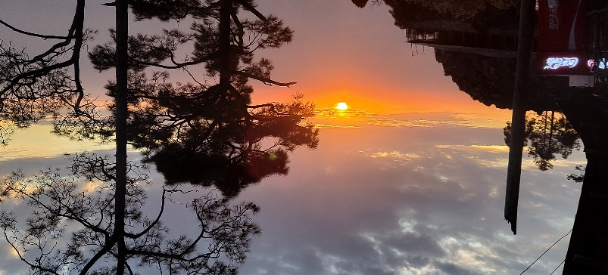

Sketch image